Penelope is polite

*At school*

*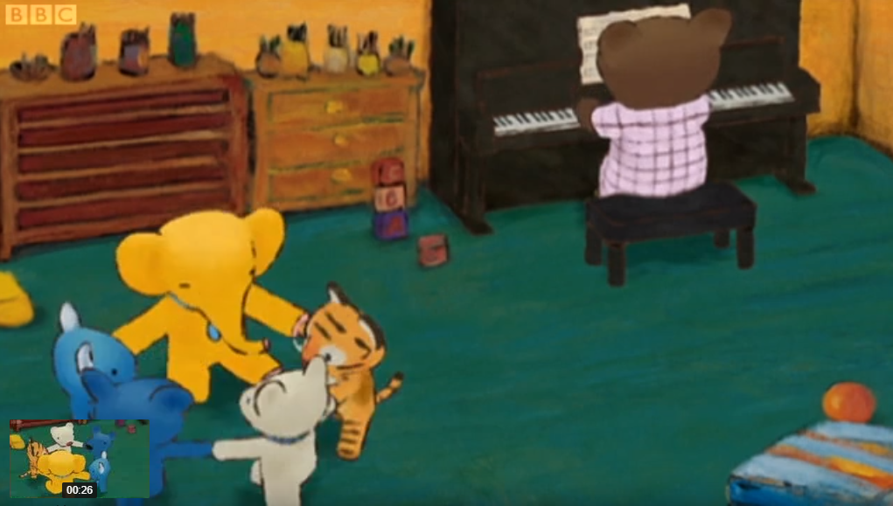*

Penelope had lots of fun at school today.

It's time to go home now.

Oh, that's my mum. Mum.

Penelope.

Let's go home.

Is she going to leave just like that? Shouldn't you say anything to your teacher and your friends before you go home?

Penelope, what do you say?

Uh? Oh, I forgot. Bye~.

That's right. You say goodbye when you leave.

Bye, Penelope. See you tomorrow.

Bye bye.

You have to be polite, Penelope.

*In the garden*

*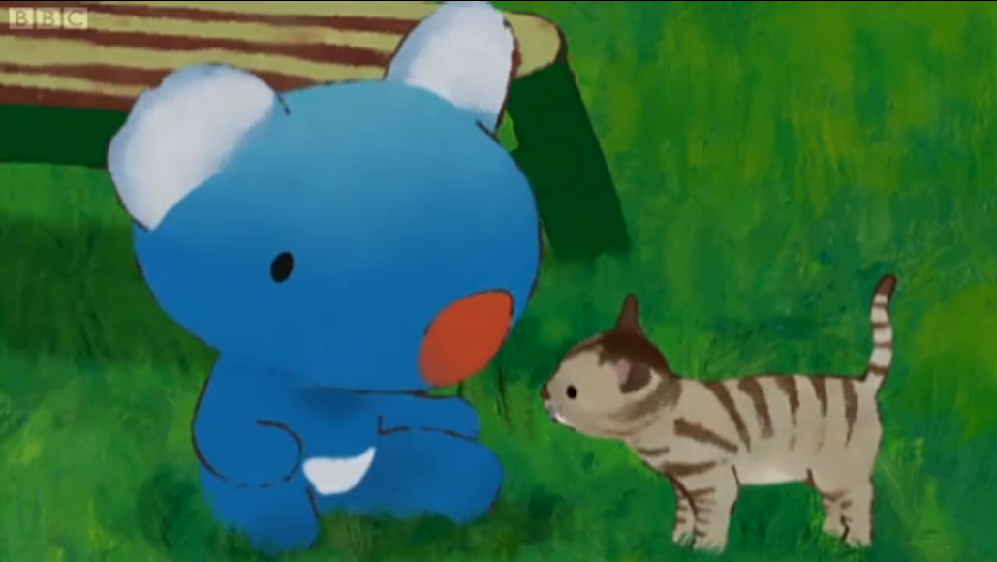*

Hey, wait. Uh? Oh.

Oh, no! Penelope stepped on the kitten's tail.

Is she all right?

Uh? You are OK?

Penelope, when you are sorry, what do you say?

I say...

Do you know what to say?

I'm sorry. It tickles.

That's right. You say I'm sorry when you do something wrong.

*In the living room*

*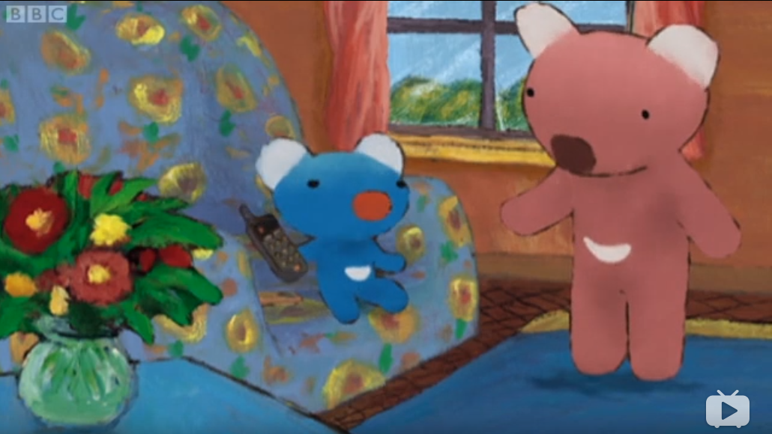*

Penelope, it's Lily Rose on the phone.

Oh, I'll ask her to play with me.

Hello, Lily Rose.

Hello, Penelope.

No greeting?

Greeting? Ah, good evening.

Em? Good evening?

That's for the evening.

Oops, I made a mistake. Good afternoon.

Good afternoon, Penelope.

That's right. You should say good afternoon.

*In the bedroom*

*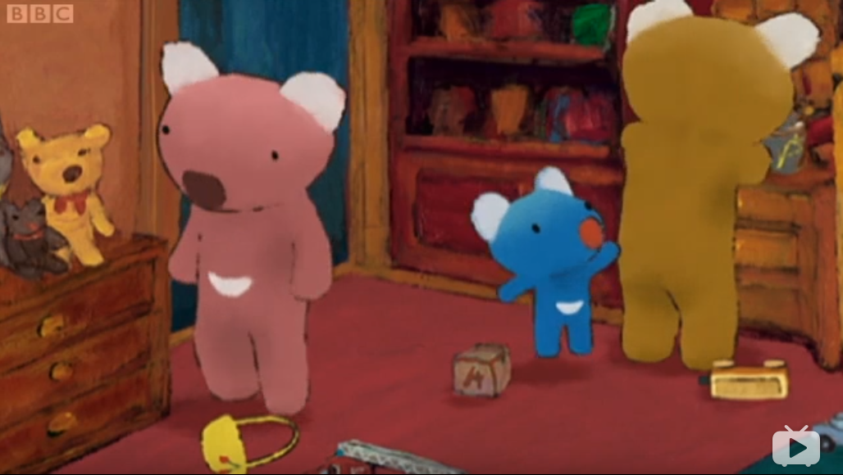*

I can't find it. Where is it?

Penelope, it's time to go to bed.

Mum, Dad, Max is missing. Max is missing.

Is he?

Yes.

Again?

I can't sleep without Max.

We'll help you find him.

Dad, have you found him?

Not yet.

Oh, now, let's see. Here is your bunny.

Yes. Dad, you found him.

And here you are.

Now what do you say to Dad for finding bunny for you?

Uh, thank you.

You are welcome.

Yes, that's right. You should say thank you.

*Still in the bedroom*

*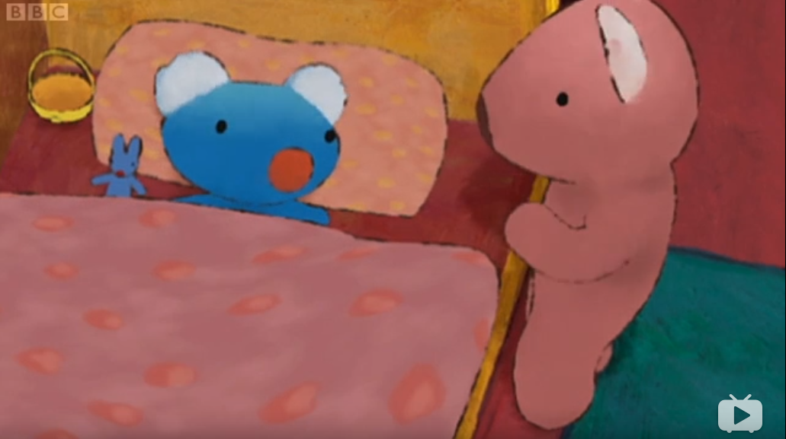*

I've learnt lots of greetings today. If I see kitten in the morning, I say good morning.

That's right.

If dad gives me the last piece of chocolate cake, I say thank you.

If I scare someone when I sneeze, I say I'm sorry.

And when you leave school, what do you say then?

I say goodbye.

Very good. You've learnt a lot today, haven't you, Penelope? But what do you say now?

Uh..Not thank you, not I'm sorry. Uh... Good night.

Good night.

Penelope learnt a lot of greetings today.